Web Application Development Log

Design Section

Project link on Github:
https://github.com/lilyhart-blip/yr12-website-development

Project name:
snake appreciation

Project Summary: Include purpose and target audience
This will be a site where people can sign up / sign in to a website where they can view posts of other peoples snakes and enclosures and rate them depending on how much they like them. Users can also post images for others to see and rate. The purpose is to be able to share your interest in snakes within the reptile community. Target audience is anyone with an interest in looking at or sharing their snakes or enclosures.

Initial Database Design ERD:

WebPage Design- Wireframe and/or Palette

Relevant Implications (explain at least 3)- Before Development.
aesthetics- this is important to have a well designed website so that the users on my website are not confused or getting lost due to poor layout. I will try to combat this by having a clear layout and reducing any clashing colours.

privacy- keeping my users data private is important to reduce the risk of it getting leaked and leading to identity theft. To reduce the risk I can try to make sure the users passwords are hashed out as well as protected in my database.

Accessibility- it is important to keep the website accessible to different types of people. By making sure buttons are clear and the text is big it helps accommodate to people who may have eyesight problems.

Sprint #1

Sprint #1 Goals
(before starting sprint 1):
-had the wireframing completed
-the erd was completed
-
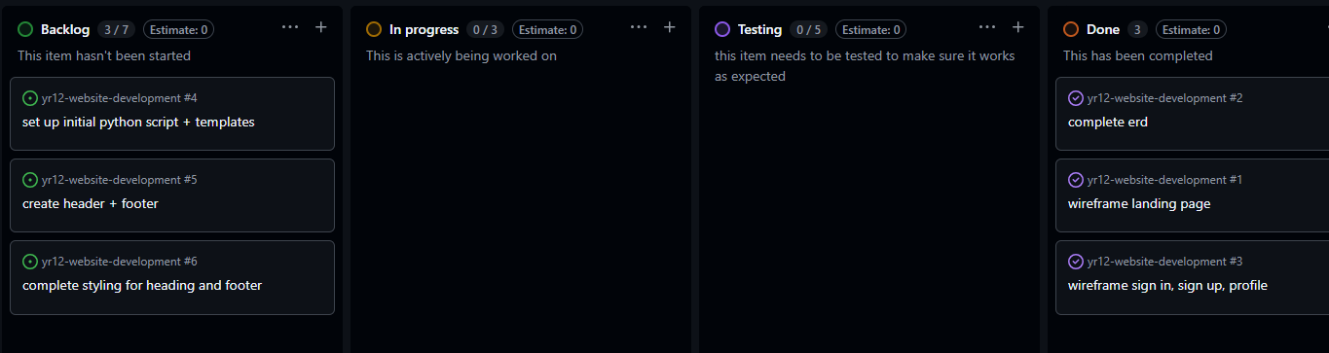

Sprint #1 Testing
Include tests for everything in your application including all links, input forms, correctness of data and correctness of queries. Add more columns as required.
Testing Table
What are you testing | How are you testing it | Expected Result | Pass/Fail
Different pages | Trying to go to different pages | There would be no 404 message when trying to navigate to other pages | pass
Aesthetics | Showing it to other people and getting their thoughts and ideas about how my website looks | I expect that there will be comments about how to improve the overall look of my website

Sprint #1 Review
Progress Review (100+ words)
The progress I made in sprint one was a good opening into the layout and function of my website. Though I did not make as much progress as I would have liked. I now have multiple different pages that the user can navigate through without complications. I also have a functional nav bar and a slight amount of css.

Sprint #2

Sprint #2 Goals
(before starting sprint):
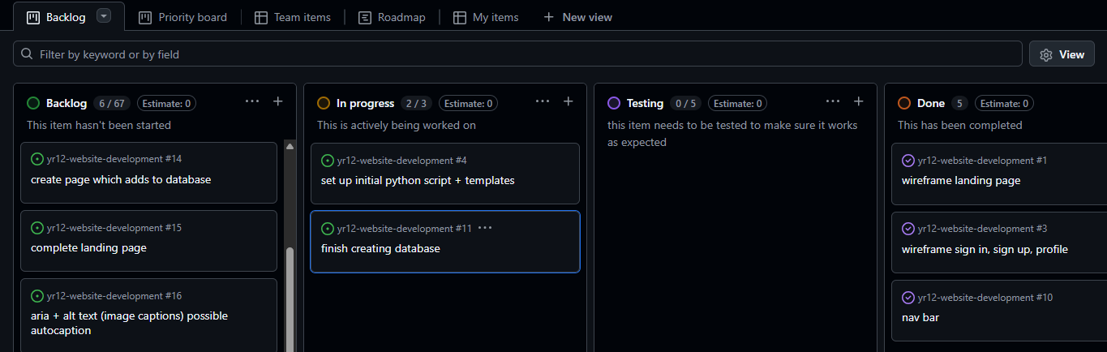

Database improvements (if any otherwise delete box)
Entity Relationship Diagram

WebPage Design Improvements (if any)- Wireframe/Sketches/Pallette/Font etc

Sprint #2 Testing
Include tests for everything in your application including all links, input forms, correctness of data and correctness of queries. Add more columns as required.
Testing Table
What are you testing | How are you testing it | Expected Result | Pass/Fail
Sign up form | Trying to input a username and password | Whatever was imputed would be transported into the database | fail

Sprint #2 Review
Progress Review (100+ words)
The progress I made during sprint two was not much. I tried to add in my database though had some struggles with it. I made a form for my sign up page where users could input their username and password to sign up, though I did not complete it as something came up in my app.py where my form was not linked correctly to my database, I will try to fix this in sprint 3.

Sprint #3

Sprint #3 Goals
(before starting sprint):
My goals for this sprint is to correctly link my database to my website as well as to put some dummy data into the db. I will also try to get some dynamic routing going in this sprint.

Database improvements (if any)
Entity Relationship Diagram

WebPage Design Improvements (if any)- Wireframe/Sketches/Pallette/Font etc

Sprint #3 Testing
Include tests for everything in your application including all links, input forms, correctness of data and correctness of queries. Add more columns as required.
Testing Table
What are you testing | How are you testing it | Expected Result | Pass/Fail

Final Review
What were the results of your testing? Did you get through all that you expected to? What is causing problems? What went well? What was a challenge? What would you do differently if you had a chance?

Discuss how planning, testing and trialling led to the development of a high-quality digital technologies outcome.

How I addressed the Relevant Implications
As discussed before the project, what relevant implications had you identified at the beginning and how did you manage to address them as you went. Were there any others that you came across while making this game? How did you manage to address them? 100+ Words

Marking Schedules: For Teacher use only

AS91892- Use advanced techniques to develop a database
Credits: 4 (internal)
NZQA: https://www.nzqa.govt.nz/nqfdocs/ncea-resource/achievements/2019/as91892.pdf

Achieved- Develop a digital outcome to manage data | Evidence | ✔
designing the structure of the data | Made an ERD
using appropriate tools and techniques to structure, organise, query and present data for a purpose and end user | Competently normalized data structure  Multiple queries across linked tables  Basic Python CRUD functionality with text input/output
applying appropriate data integrity and testing procedures | Testing Logs. Do the queries work and return what is expected?
Explaining relevant implications. | Relevant Implications Questions answered appropriately
Merit- Develop an informed digital outcome to manage data
using information from testing procedures to improve the quality of the database | Suggested improvements implemented- improve database design, add or refine entities or tables and relationships  Made improved ERD(s)
structuring, organising and querying the data logically | No problems with structure and datatypes in the table. No wildcard queries, JOIN’s used efficiently.  2NF at least.
addressing relevant implications. | The outcome addresses the relevant implications mentioned
Excellence- Develop a refined digital outcome to manage data
iterative improvement throughout the design, development and testing process | Improved functionality of database and refinements to structure of the data.
presenting the data effectively for the purpose and to meet end-user requirements. | Very refined outcome providing all needed functionality

AS91893 - Use advanced techniques to develop a digital media outcome
Credits: 4 (Internal)
NZQA: https://www.nzqa.govt.nz/nqfdocs/ncea-resource/achievements/2019/as91893.pdf

Achieved | Evidence | ✔
using appropriate tools and techniques for the purpose and end users | Coded a website in HTML and CSS. Looks and functions mostly like intended in the design.
applying appropriate data integrity and testing procedures | It functions as intended and the right pages show with the correct data when the links are clicked
using relevant conventions for the media type | Site has basic usability (HCI)
explaining relevant implications. | Relevant conventions section completed adequately
Merit
using information from testing procedures to improve the quality of the outcome | Testing and sprint reviews show evidence of specific improvement made based on the testing. No lorem ipsum anymore!! Accurate Data
applying relevant conventions to improve the quality of the outcome | Decent HCI. Eg. generally shows “consistency and standards”, and/or “help and documentation” by having an about page.
addressing relevant implications. | Has met relevant implications like NOT used copyright material, addresses privacy by keeping data safe (eg hashed passwords) etc.
Excellence
iterative improvement throughout the design, development and testing process to produce a high-quality outcome | Must be high quality. No obvious errors or inaccurate data.
using efficient tools and techniques in the outcome’s production. | Kept a good log, used github to keep backups and record of work, lots of commits on github.

AS91896 - Use advanced programming techniques to develop a computer program

Credits: 6 (Internal)
NZQA: https://www.nzqa.govt.nz/nqfdocs/ncea-resource/achievements/2019/as91896.pdf

Achieved | Evidence | ✔
writing code for a program that performs a specified task | Applications works as intended.
using advanced techniques in a suitable programming language | “creating methods, functions, or procedures that use parameters and/or return values” flask requires that  “responding to events generated by a graphical user interface (GUI) ”- links in webpage run routes that do queries  “using additional non-core libraries”- using Flask.
setting out the program code clearly and documenting the program with comments | Some code comments, code layed out relatively cleanly with constants/variable at the top, routes and functions after.
testing and debugging the program to ensure that it works on a sample of expected cases. | Testing table shows the basic web page functionality was tested.
Merit
documenting the program with appropriate names and comments that describe code function and behaviour | Good variable and function names. Good and plentiful code comments.
following common conventions for the chosen programming language | PEP8 Followed. Use Pylint or similar and check linting.
testing and debugging the program effectively to ensure that it works on a sample of both expected cases and relevant boundary cases. | Lots of testing including request for non-existent id returning an error 404 page.
Excellence
ensuring that the program is a well-structured, logical response to the specified task | Enhanced program, e.g. functions that aren’t routes to make the code cleaner (eg query_db). Neat and logical code.
making the program flexible and robust | Great structure making code easy to extend. Unbreakable code. Eg. Error-404 and error 505 handlers
comprehensively testing and debugging the program. | Unbreakable code with a lot of tests done for every testable element of the program including unexpected input like a non existent route or page returning custom error 404 handler

